Environments
Jenkins Server: 192.168.145.78:8080
PG Client Server: 192.168.145.12
PG database Server: 192.168.145.30
Git Server :192.168.145.78:3000

Preparation before implementation

PG Client Server
All the scripts that need to be called on the client are putted in the / tmp directory.
The going online sql files obtained from git server will be placed in /tmp/postgres/deploy_sqls/scripts/

mkdir -p /tmp/postgres/deploy_sqls/scripts/

/tmp/db_check.sh:

#!/bin/bash
db_host=192.168.145.30
db_port=1921
db_username=dbai
export PGPASSWORD='123456'
db_name=postgres

/opt/pg11.4/bin/psql -h $db_host -U $db_username -p $db_port -d $db_name -c "select 1"

if [ $? -ne 0 ] ;then
echo "Database Connectivity testing Fail"
exit 1

else
echo "Database Connectivity testing Success"
exit 0
fi

/tmp/db_execute.sh：
#!/bin/bash
db_host=192.168.145.30
db_port=1921
db_username=dbai
export PGPASSWORD='123456'
db_name=postgres

MYDATE=`date +%Y%m%d`
PG_PATH=/tmp/postgres/deploy_sqls/scripts/
LOG_FILE=${PG_PATH}/exec_${MYDATE}.log
ERR_FILE=${PG_PATH}/error.log

cd $PG_PATH
echo -e "\n===========start `date +%Y%m%d%H%M%S`=============\n" > $LOG_FILE

/opt/pg11.4/bin/psql -h $db_host -U $db_username -p $db_port -d $db_name -a -1 -f main.sql >& ${ERR_FILE}

cat ${ERR_FILE} >>${LOG_FILE}
error=`grep ERROR $ERR_FILE`
if [ -n "$error" ] ; then
echo -e "\n=========== Sql File Eexcute Fail,please modify sql file and rerun the error sql =============\n" >>${LOG_FILE}
cat ${LOG_FILE}
exit 1

else
echo -e "\n=========== Sql File Eexcute Successfully =============\n" >>${LOG_FILE}
echo -e "\n===========end=============\n" >>${LOG_FILE}
cat ${LOG_FILE}
exit 0
fi

/tmp/db_rollback.sh
#!/bin/bash
db_host=192.168.145.30
db_port=1921
db_username=dbai
export PGPASSWORD='123456'
db_name=postgres

MYDATE=`date +%Y%m%d`
PG_PATH=/tmp/postgres/deploy_sqls/scripts/
LOG_FILE=${PG_PATH}/rollback_${MYDATE}.log
ERR_FILE=${PG_PATH}/rollback_error.log

cd $PG_PATH
echo -e "\n===========start `date +%Y%m%d%H%M%S`=============\n" > $LOG_FILE

/opt/pg11.4/bin/psql -h $db_host -U $db_username -p $db_port -d $db_name -a -1 -f rollback.sql >& ${ERR_FILE}

cat ${ERR_FILE} >>${LOG_FILE}
error=`grep ERROR $ERR_FILE`
if [ -n "$error" ] ; then
echo -e "\n=========== Sql File Eexcute Fail,please modify sql file and rerun the error sql =============\n" >>${LOG_FILE}
cat ${LOG_FILE}
exit 1

else
echo -e "\n=========== Sql File Eexcute Successfully =============\n" >>${LOG_FILE}
echo -e "\n===========end=============\n" >>${LOG_FILE}
cat ${LOG_FILE}
exit 0
fi

PG Database Server
Create database user to execute online sql file.
create user DBAi with password '123456';
alter user DBAi with superuser NOCREATEDB NOCREATEROLE NOINHERIT NOREPLICATION ;

Git Server
directory structure:
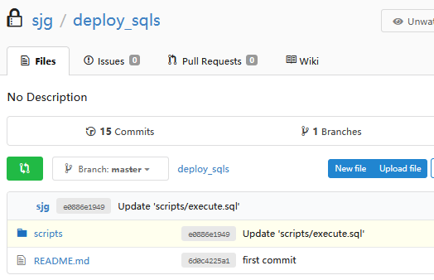
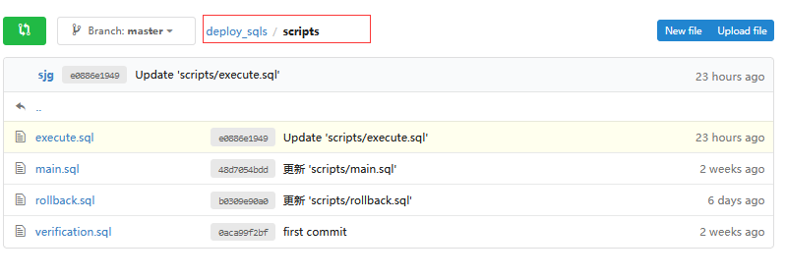
main.sql
#use to call execute.sql
\i execute.sql
\i verification.sql

execute.sql
#SQL script ready to go online
#for example:
\c test_db2;
set session authorization klk;
begin;
drop table IF EXISTS testdb2_t1;
drop table IF EXISTS testdb2_t2;
create table testdb2_t1 (id int);
create table testdb2_t2 (id int);
create index idx_db2 on testdb2_t1(id);
create index idx2_db2 on testdb2_t2(id);
insert into testdb2_t1 values (1);
end;

rollback.sql
#SQL script ready to rollback
#for example:
\c test_db2;
set session authorization klk;
begin;
drop table IF EXISTS testdb2_t1;
drop table IF EXISTS testdb2_t2;
end;

verification.sql
put some sql if you like

Implementation steps

Setting Jenkins Serve connect to PG Client Server

"manage jenkins" > "Configure System"

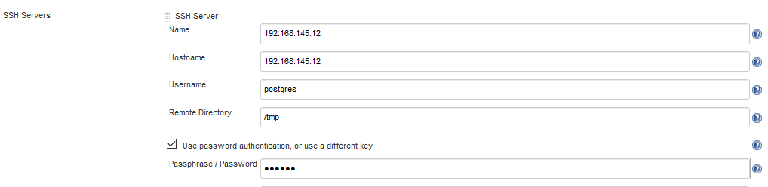

Database Connectivity testing

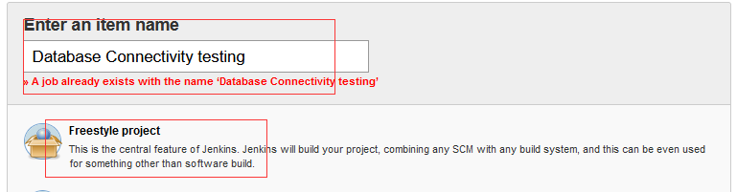

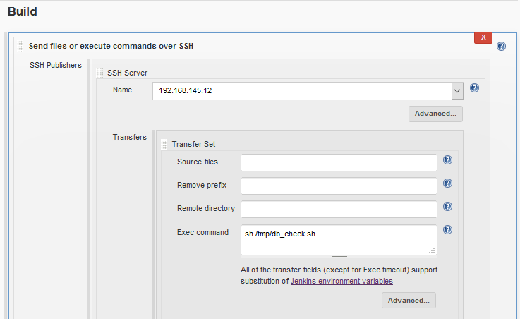
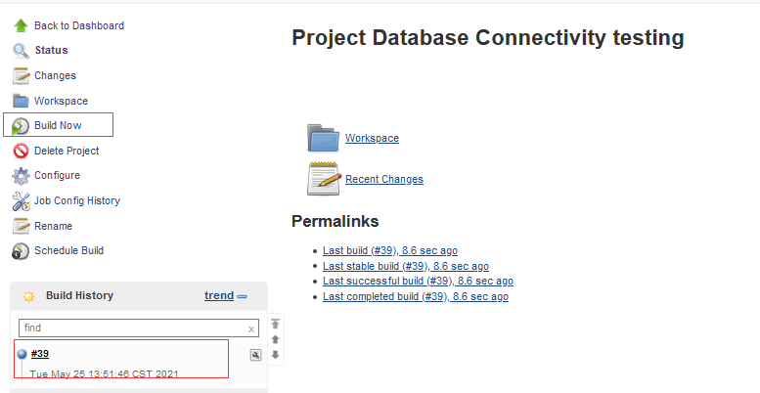

Transfer_Sql_Scripts2
Get the newest version sql file from git,then transfer sql fie to PG client server.
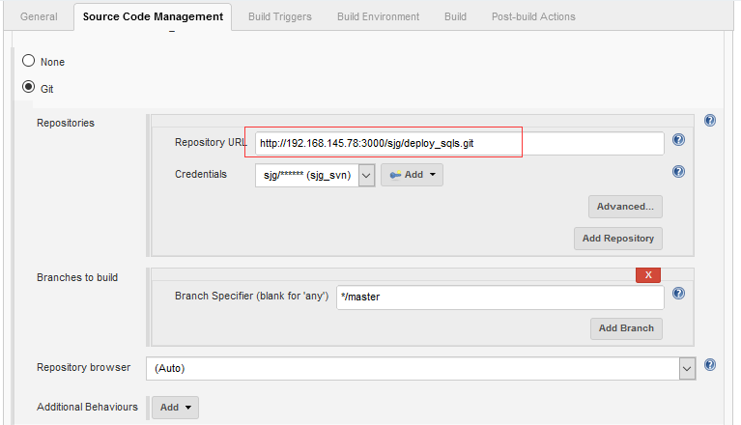

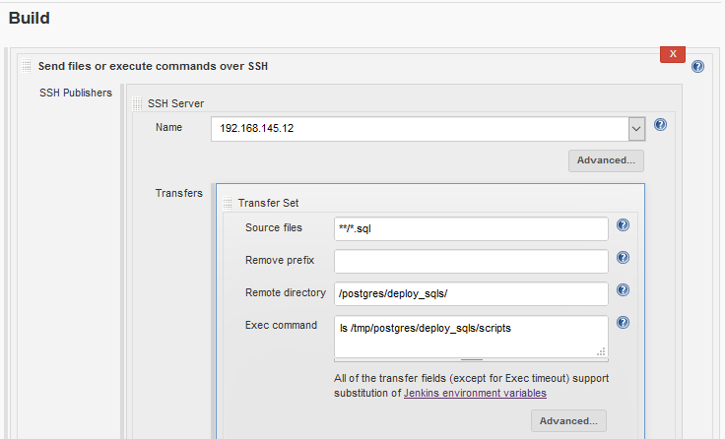
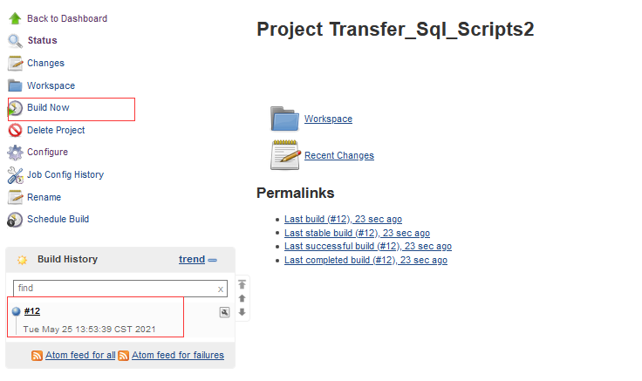

permission set for postgres2
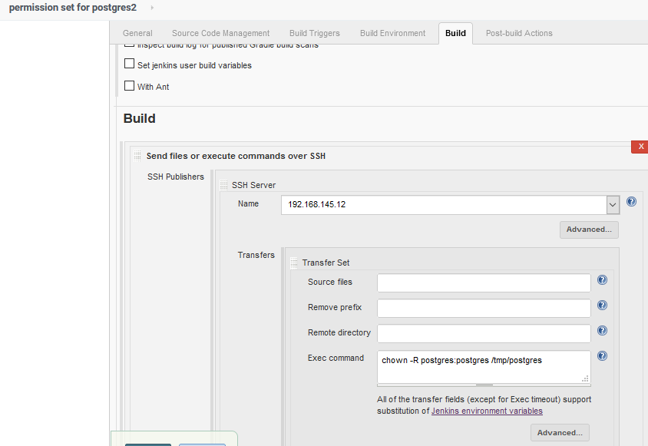
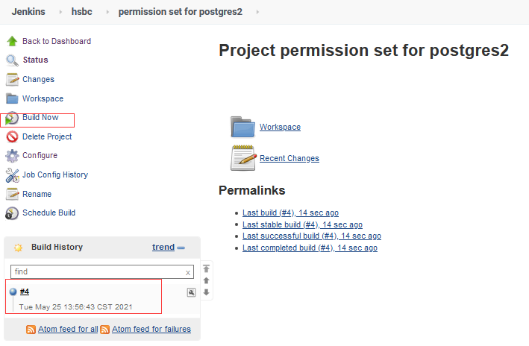

Execute DB scripts
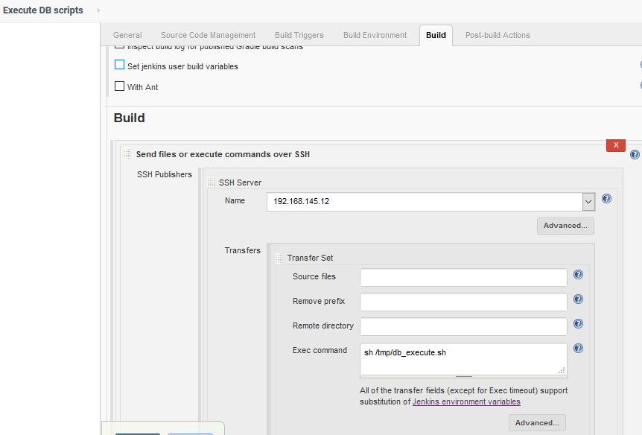
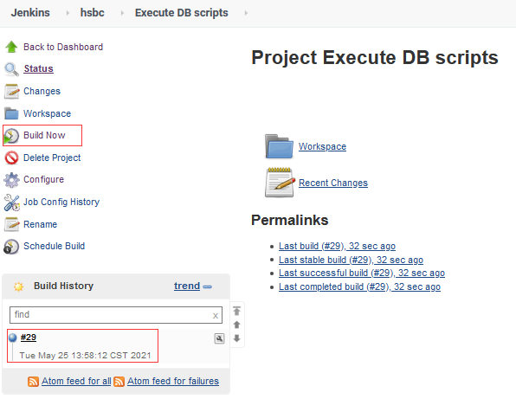

Rollback DB scripts
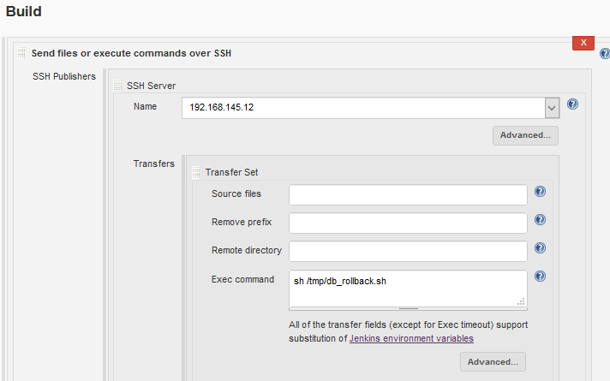
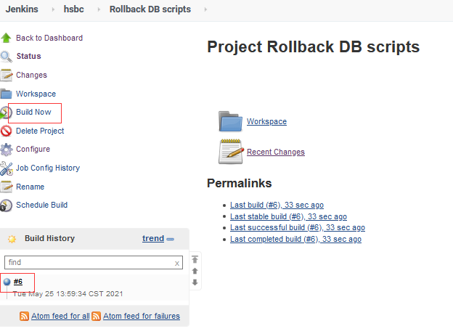

sql_deploy_pipe2
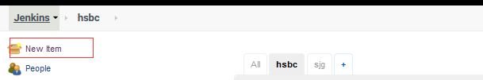

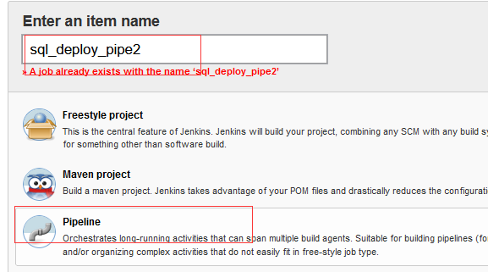

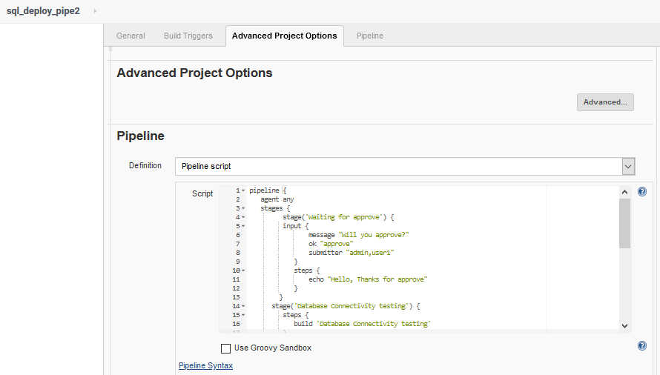

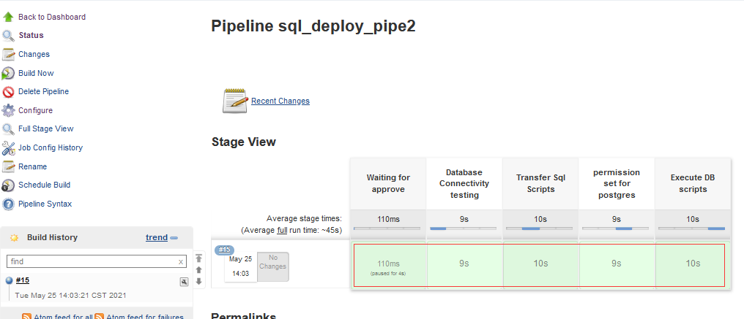

pipeline {
agent any
stages {
stage('Waiting for approve') {
input {
message "Will you approve?"
ok "approve"
submitter "admin,user1"
}
steps {
echo "Hello, Thanks for approve"
}
}
stage('Database Connectivity testing') {
steps {
build 'Database Connectivity testing'
}
}
stage('Transfer Sql Scripts') {
steps {
build 'Transfer_Sql_Scripts2'
}
}
stage('permission set for postgres') {
steps {
build 'permission set for postgres2'
}
}

stage('Execute DB scripts') {
steps {
build 'Execute DB scripts'
}
}
}
}

sql_rollback_pipe2
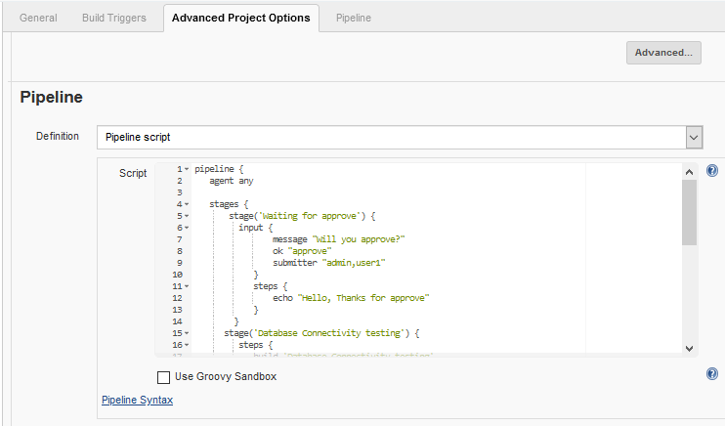
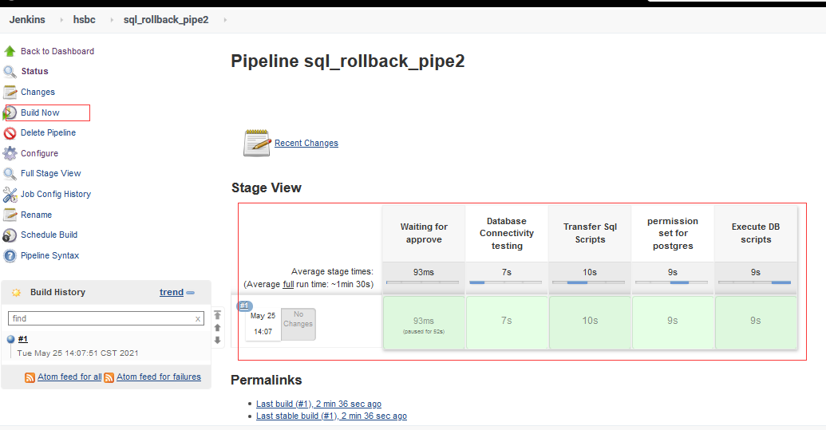

pipeline {
agent any

stages {
stage('Waiting for approve') {
input {
message "Will you approve?"
ok "approve"
submitter "admin,user1"
}
steps {
echo "Hello, Thanks for approve"
}
}
stage('Database Connectivity testing') {
steps {
build 'Database Connectivity testing'
}
}
stage('Transfer Sql Scripts') {
steps {
build 'Transfer_Sql_Scripts2'
}
}
stage('permission set for postgres') {
steps {
build 'permission set for postgres2'
}
}
stage('Execute DB scripts') {
steps {
build 'Rollback DB scripts'
}
}
}
}

Permission control
set the permission policy based on project authorization

"Manage Jenkins" > "Configure Global Security"
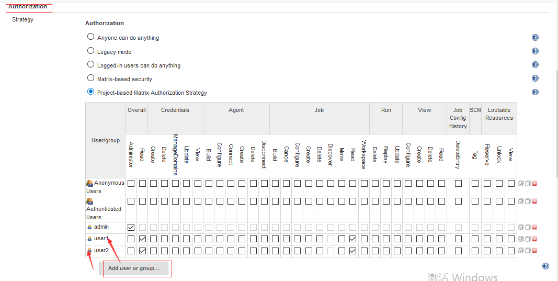
For sql_deploy_pipe2 & sql_rollback_pipe2, set read, build and cancel permissions for user：

